

**Draft**

**Tour itinerary for Expedition Cruise Ships- new Wharf**

Tour times (2 offerings per day)

**$NZ120** per person

Tour groups of 40 to 80 people per venue

Maximum current capacity 680 people per day

Season: October to April – 2 ships per month (10 per annum)

* **8.30 am 11am**
* **11am to 2.30pm**

Tour A

Come to a different place and Time

Like yourselves Maori also came to Aotearoa over the water.

Join us as we recreate for you how the anscetors of our mighty forebearer “Kupe” arrived and were warmly welcomed onto local marae. Feel as they did when they marvelled at the many splendours of this great land.

Join us as we show you how local Maori live in and with nature. Hear the whispering of the winds , the roar of the ocean and the song of the bush – the many voices of Aotearoa.

**Stop 1**Kauaetangohia Marae (Whangaparoa) visit

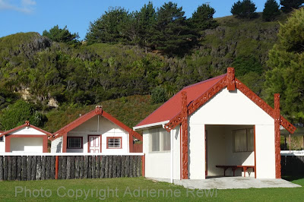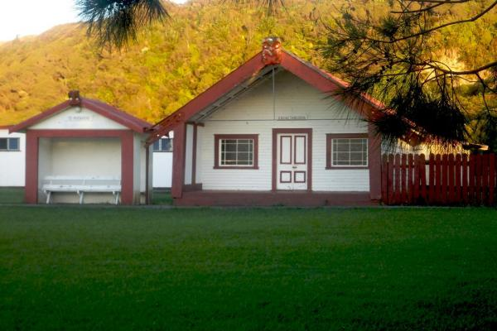

Maori warriors were strong and fearless. Come and see the wero (challange) and be welcomed onto the marae with the Powhiri. See local women as they prepare and weave flax.

Sample the unique flavour and smells of Hangi food – how food was cooked in the ground ovens.

Hear the significance of Ta Moko- the ancient maori tradition of facial tattos. See what significance the designs of each unique tattoo has. Enjoy the cultural dances (Kapa haka) performed by local people

See how Maori gathered and met at their local marea , the central place of Hapu (families).

**Stop 2**

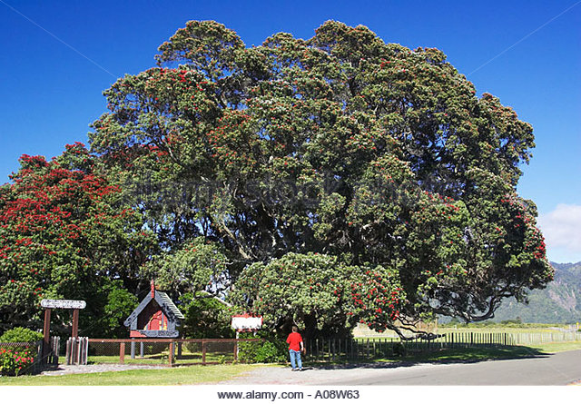 Visit the world's biggest pohutukawa tree

Stop 3

Tiki Tiki – St Marys Church 50 km away . 50 min drive

Come visit St Mary’s church in Tikitiki that serves as a memorial to the Māori men from the East Coast who fought and died in the First World War. St Mary’s is regarded as one of the most beautiful Māori churches in New Zealand. St Mary’s church was built on the site of Pukemaire pā, where a battle was fought in 1866 between Christian and Pai Marire (‘Hauhau’) factions of Ngāti Porou.

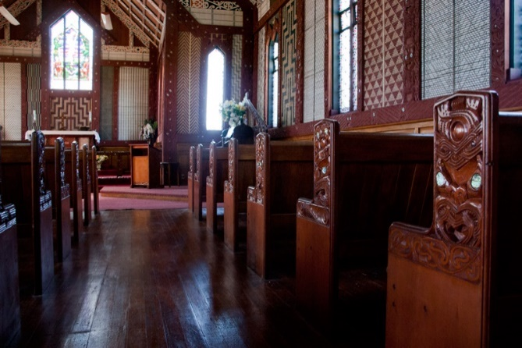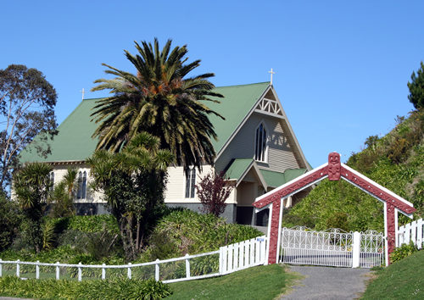

Stop 4

Waka on the beach Tiki Tiki

Come and see master carvers plying their craft on an authentic waka. Ngati Porou the area iwi (tribe) named the waka Te Aio o Nukutaimemeha, which means the "peaceful, calm Nukutaimemeha [45m waka of safe passage]".

[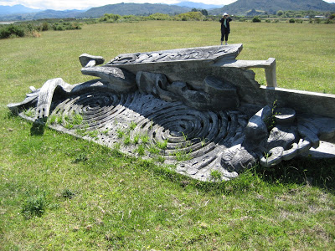](http://1.bp.blogspot.com/_YWqtqq5x6VY/R0-kCQ52VZI/AAAAAAAAAa8/qSDvKJZUGZ0/s1600-R/112+Tiki+Tiki+L+Waka+Waiapu+River+DEC3006.jpg)[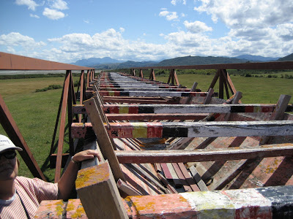](http://2.bp.blogspot.com/_YWqtqq5x6VY/R0-hBg52VWI/AAAAAAAAAak/lsHQjrpVNVM/s1600-R/113+Tiki+Tiki+M+Waka+Waiapu+River+DEC3006.jpg)

I

Stop 6

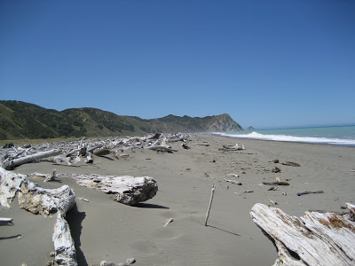A short, secluded beach walk of the area. 

**Tour B**

NZ Apiary/Agricultural experience

Stop 1

Manuka Honey Factory

From this land, in the land of the long white cloud, comes one of nature’s miracle cures. Now being used to treat medical patients who are resistant to antibiotic dressing is Honey form the Manuka tree. This highly prized and rare honey sells for more than Gold per ounce. See how it is processed, taste samples and buy small bottles to help heal wounds, cure sore throats and increase you immune system.

See Beehives See extraction to drums

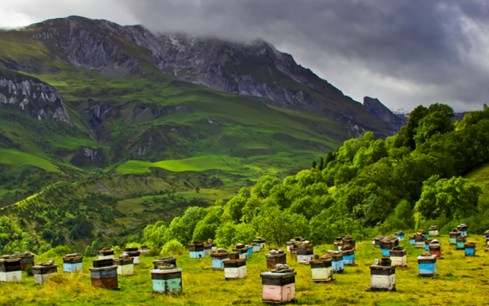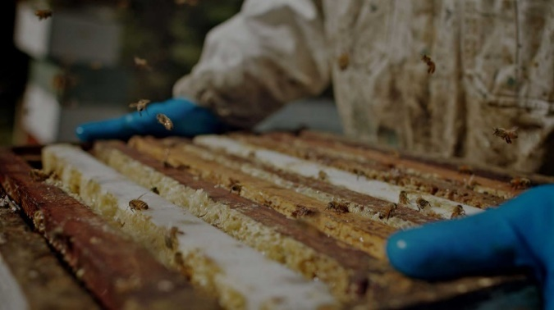

Buy pots of local Manuka Honey (sample pictures only)

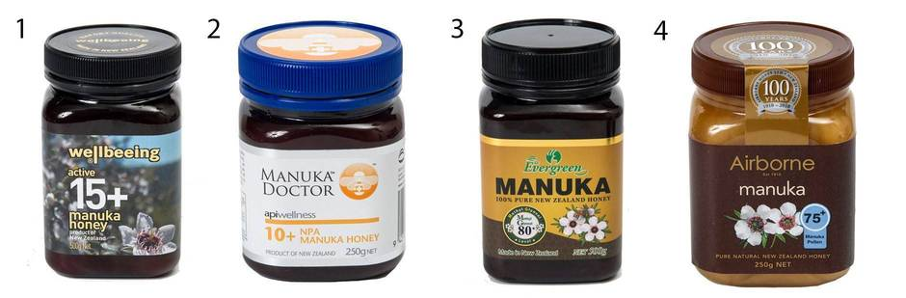

Stop 2

Agricultural show

New Zealand in the 1950’s was the wealthiest nation (per head) in the world. Its economy was based on shipping meat, wool and diary to “Mother” England. See what “the backbone of New Zealand” is really like firsthand, the day-to-day life in NZ farmers.

Sheep shearing barn. See NZ master sheep shearers plying their trade

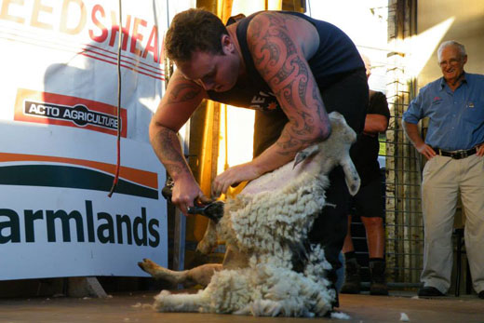

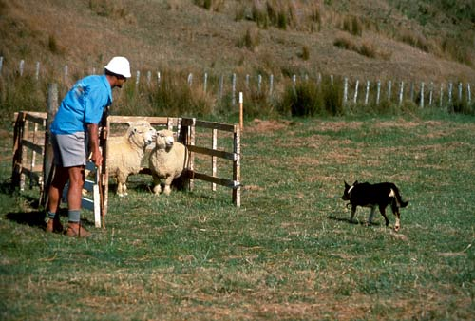**Dog handling show.** Dogs were not only a “man’s best friend” but formed a bond with NZ farmers and were basically another “man” to help control farm animals. See “working dogs “in action.

Stop 3

Waihirere Falls & Bush walk

Come for a gentle walk-through NZ native bush and enjoy the native ferns and birdsong. Listen as the earth talks to you like it spoke to our ancestors

[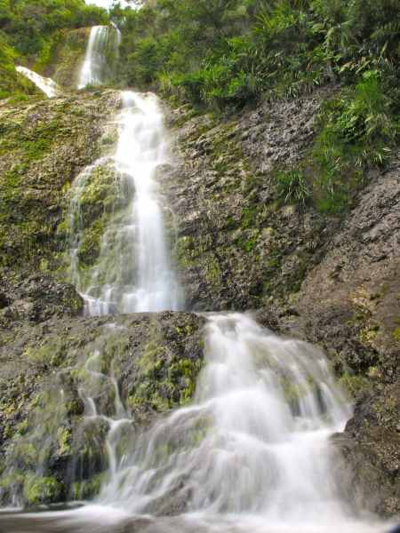](https://nzfrenzynorth.files.wordpress.com/2013/07/slow-shutter-at-waihirere-falls.jpg)[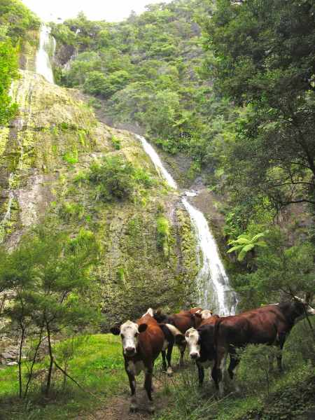](https://nzfrenzynorth.files.wordpress.com/2013/07/tall-waihirere-falls-and-a-herd-of-curious-cows.jpg)

Activities at Whangaparaoa Bay

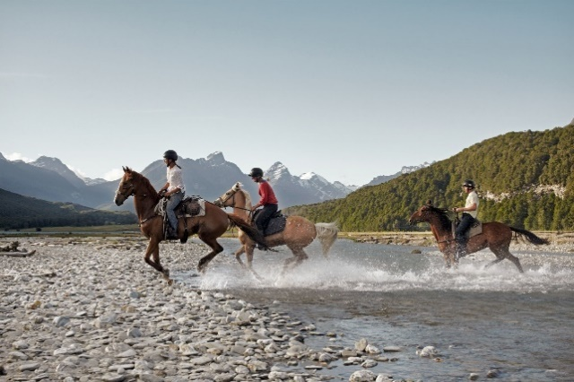Horse trek Whangaparaoa point

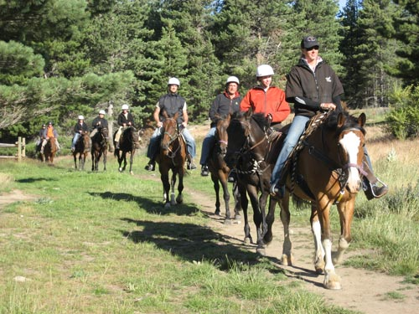

Craft market Whangaparaoa

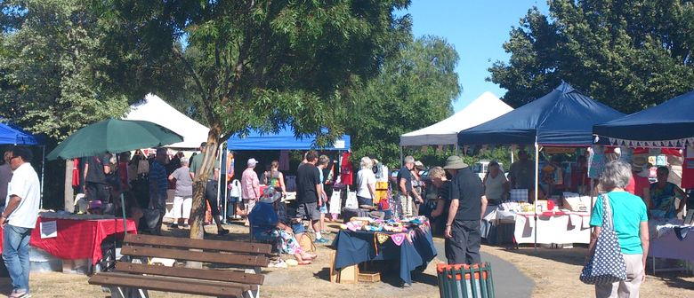

Raukokore church

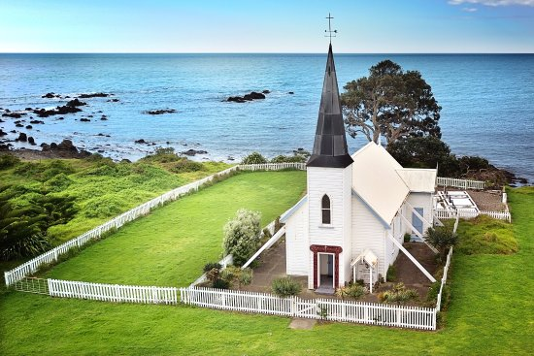

TERRAFERMAH IN CONJUNCTION WITH ANY INTERESTED PARTNERS

EXPEDITION CRUISE SHIP TOURISIM

High spending affluent tourists

10 days per year in port estimated 680 people per day

Up to 106 full and part time jobs created

Two tours per day split into manageable groups of 40 to 80

**TOUR OPTION C**

Waihau Bay

**Half day “once in a lifetime” fishing trip on the edge of a continental shelf!**

Waihau Bay was the setting of Taika Waititi’s 2010 blockbuster movie *Boy*. Waititi, who both starred in and directed the film, grew up around these parts. He reckons he was inspired by ‘true and imagined memories’ when writing the film. In real life, life in the bay revolves around the general store and the pub, which sit happily alongside each other.

Take a fishing trip out to the Ranfurly bank from this wharf. The Ranfurly Banks off the North Island’s East Cape is a place world-renowned as a Mecca for monster fish. This is a place where fishing dreams come true. People have described their trip to ‘the Banks’ as the best day’s fishing of their lives. Twenty-five nautical miles offshore, this isolated area extends 30 kilometres in every direction. The bathymetry is incredible, with depths ranging from 1000 metres to 15 metres, set amongst impressive underwater mountains and valleys. The Banks lays on the edge of the continental shelf (the section of ocean between the coast and the deep ocean floor). Nutrient-rich waters draw all forms of sea life for obvious reasons – there is plenty of kai (food)! Here you will find big fish near the surface such as Hapuka, Bass, Kingfish, Trumpeter, King Terakihi and game fishing for blue and striped marlin, broadbill swordfish and various species of tuna.

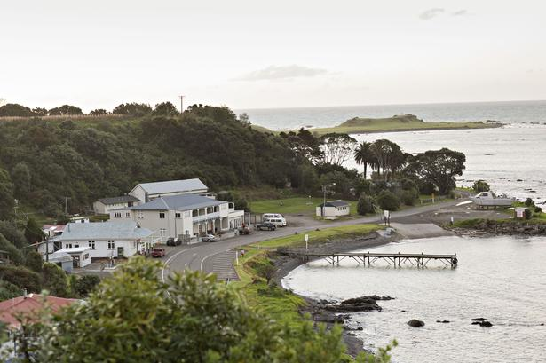

Cruise boat tours ticketing office



